1. Manifest File
A manifest file is simply a YAML file that tells Kubernetes:
“What do I want Kubernetes to create?”
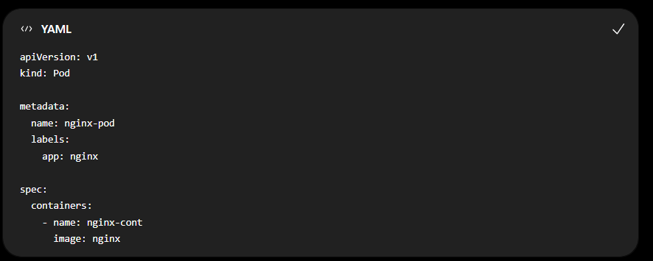
Save as:
pod.yaml
Create it:
kubectl apply -f pod.yaml
Check:
kubectl get pods
Remember
YAML file → kubectl apply → Kubernetes creates resource

2. Service Manifest
A Service gives network access to a Pod.
Example:
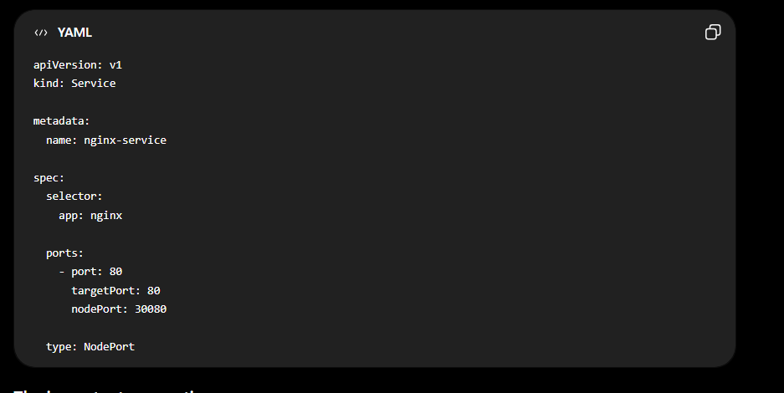
Create it:
kubectl apply -f service.yaml
Check:
kubectl get svc
Important
Pod:
labels:
app: nginx
Service:
selector:
app: nginx
They must match.

3. Namespace
Namespace = separate area inside a Kubernetes cluster.
Think of it like folders.
Kubernetes Cluster
│
├── default
│
├── development
│
└── production
Create:
kubectl create namespace dev
Check:
kubectl get namespaces
Create a Pod inside it:
kubectl apply -f pod.yaml -n dev
See Pods in that namespace:
kubectl get pods -n dev
Easy definition
Namespace = used to separate/group resources inside a cluster.

4. ReplicaSet
A ReplicaSet keeps a specific number of Pods running.
Example:
ReplicaSet
│
├── Pod
├── Pod
└── Pod
If you say:
replicas: 3
Kubernetes tries to keep 3 Pods running.
Example YAML:
apiVersion: apps/v1
kind: ReplicaSet

metadata:
name: nginx-rs

spec:
replicas: 3

selector:
matchLabels:
app: nginx

template:
metadata:
labels:
app: nginx

spec:
containers:
- name: nginx
image: nginx
Create:
kubectl apply -f replicaset.yaml
Check:
kubectl get replicasets
Check Pods:
kubectl get pods
You'll get approximately:
nginx-rs-xxxxx
nginx-rs-yyyyy
nginx-rs-zzzzz
Easy definition
ReplicaSet = keeps the required number of Pods running.
For example:
replicas: 3

Want: 3 Pods
Have: 2 Pods
→ creates 1 more

Want: 3 Pods
Have: 3 Pods
→ does nothing

5. ReplicationController
ReplicationController is the older version of ReplicaSet.
Its main job is also:
Keep a certain number of Pods running.
Example:
ReplicationController
│
├── Pod
├── Pod
└── Pod
Basic YAML:
apiVersion: v1
kind: ReplicationController

metadata:
name: nginx-rc

spec:
replicas: 3

selector:
app: nginx

template:
metadata:
labels:
app: nginx

spec:
containers:
- name: nginx
image: nginx
Check:
kubectl get replicationcontrollers
Important for students
You normally learn ReplicaSet, not ReplicationController, for modern Kubernetes.
ReplicationController → Old
ReplicaSet → Newer
Deployment → Commonly used today

⭐ Super Easy Difference
Resource | Easy meaning
Pod | Runs your container/application
Service | Gives network access to Pods
Namespace | Separates/groups resources
ReplicaSet | Keeps required number of Pods running
ReplicationController | Older way to keep Pods running
Remember this picture
Kubernetes Cluster
│
├── Namespace
│
├── ReplicaSet
│ │
│ ├── Pod
│ ├── Pod
│ └── Pod
│
└── Service
│
└── connects to Pods
Most important commands
kubectl get pods
kubectl get nodes
kubectl get svc
kubectl get namespaces
kubectl get replicasets
kubectl get replicationcontrollers
And for YAML:
kubectl apply -f filename.yaml
One-line memory:
Pod = run, Service = connect, Namespace = separate, ReplicaSet = maintain Pods.

